



Charging Station for ISO / IEC 15118 Protocol

*Building a working smart networked charging station with support for both ISO 15118 and*

*IEC 61851*

Bachelors Project

**Presented by**

Jiztom Kavalakkatt Francis

Nivas Gokul Manimurugesan

Raphael Scholz

**Supervisor:** Prof. Dr.-Ing. Ansgar Meroth, Hochschule Heilbronn

Hochschule Heilbronn / Heilbronn University

Faculty of Mechanics und Electronics

Automotive Systems Engineering

**Table of Contents**

**Contents III**

**Abstract IV**

**List of tables V**

**List of Figures VI**

**List of Symbols and Abbreviations VII**

1. **Introduction**
   1. Short Version
   2. Task
   3. Chapter Overview
2. **Literature Survey**
   1. Scholastic survey
   2. Reference
3. **Problem Definition / Objective**
4. **Methodology**
   1. IEC 62196 : Charging Plug
   2. IEC 61851
   3. ISO/IEC 15118
      1. Open v2g project
   4. TCP/IP communication
   5. UML
      1. UML State Machine Diagram
      2. UML Sequence Diagram
   6. Automatic State Machine
5. **Software Description**
   1. Filezilla
   2. Geany
   3. Putty Terminal
   4. EB GUIDE 6.3
   5. www.draw.io
   6. Visual Paradigm 14.0
   7. gcc compiler on Linux terminal
6. **Hardware Description**
   1. Raspberry Pi 3 with 7” Capacitive Touch screen
   2. EVAChargSE Board
   3. Communication between EVSE and EV
   4. Communication between EVSE and Raspberry Pi
   5. Integrating the system
   6. Testing the system using dummy parameters.
7. **Results**
8. **Conclusion**
9. **Summary & Outlook**
10. **Attachments**

**Bibliography**

**Abstract**

**List of Tables**

**List of Figures**

**List of Symbols and Abbreviations**

1. Introduction

In this chapter a short summary of this work is described. In addition, the task description as well as to overview of the following chapters and their contents are given.

* 1. Short Version

The present project work serves to set up a working model for the current standardization of the vehicle-column communication according to ISO / IEC 15118 along with the HMI display.

The built-up working model consists of two interconnected boards and a Raspberry Pi for teh display. Each communication user is represented by a circuit board.

The software used is derived from an existing stack and adapted for a defined application of ISO / IEC 115118.

According to the ISO variable parameters are listed as macros and documented, so that a change is possible at any time. If parameters are selected so that the resulting requirements can no longer be met by the respective other subscriber, a fault message is output.

* 1. **Task**

The main task is to implement a basic working model of the car charging station with the HMI interfaced into the system. It involves the study of the basic working of the ISO 15118 protocol and defining the possible working structure of the Charging station.

The task involves the design of the communication mechanisms and processes between the main processor of an electric vehicle supply equipment (EVSE) – or called charging station - and an computer that runs the HMI on that EVSE (HMI), and the electric vehicle to be charged (EV)

The targets achieved:

- Analysed the requirements of ISO 15118 and IEC 61851 based on the work of the references.

- Designed, discussed and finalized the state machine and the communication process between EVSE and HMI together with a German student (Raphael Scholz)

- Learned about UML as a description language for state machines and communication sequences

- Experienced TCP/IP communication with practical training on a Linux system

- Started coding for the implementation of the above

* 1. Chapter Overview

1. Literature Survey
   1. Scholastic Survey

The following were considered for the initial study of the Car Charging Process

* + 1. **Automotive Ethernet: in-vehicle networking and smart mobility**

**Authors:**

* Peter Hank NXP Semiconductors, Hamburg, Germany
* Steffen Müller NXP Semiconductors, Hamburg, Germany
* Ovidiu Vermesan SINTEF, Oslo, Norway
* Jeroen Van Den Keybus Triphase NV, Leuven, Belgium

**Proceedings**

DATE '13 Proceedings of the Conference on Design, Automation and Test in Europe

Pages 1735-1739

Grenoble, France — March 18 - 22, 2011

**Abstract:**

This paper discusses novel communication network topologies and components and describes an evolutionary path of bringing Ethernet into automotive applications with focus on electric mobility. For next generation in-vehicle networking, the automotive industry identified Ethernet as a promising candidate besides CAN and FlexRay. Ethernet is an IEEE standard and is broadly used in consumer and industry domains. It will bring a number of changes for the design and management of in-vehicle networks and provides significant re-use of components, software, and tools. Ethernet is intended to connect inside the vehicle high-speed communication requiring sub-systems like Advanced Driver Assistant Systems (ADAS), navigation and positioning, multimedia, and connectivity systems. For hybrid (HEVs) or electric vehicles (EVs), Ethernet will be a powerful part of the communication architecture layer that enables the link between the vehicle electronics and the Internet where the vehicle is a part of a typical Internet of Things (IoT) application. Using Ethernet for vehicle connectivity will effectively manage the huge amount of data to be transferred between the outside world and the vehicle through vehicle-to-x (V2V and V2I or V2I+I) communication systems and cloud-based services for advanced energy management solutions. Ethernet is an enabling technology for introducing advanced features into the automotive domain and needs further optimizations in terms of scalability, cost, power, and electrical robustness in order to be adopted and widely used by the industry.

* + 1. **Towards standardized Vehicle Grid Integration: Current status, challenges, and next steps**

**Authors:**

* BO chen Argonne National Laboratory, USA
* Keith S. Hardy Argonne National Laboratory, USA
* Jason D. Harper Argonne National Laboratory, USA
* Daniel S. Dobrzynski Argonne National Laboratory, USA

**Published in:** Transportation Electrification Conference and Expo (ITEC), 2015 IEEE

**Abstract:**

This paper studies what are needed to enable the standardization of Vehicle Grid Integration (VGI). The requirements of interoperable VGI are examined at multiple interoperability layers defined by reference architecture models, including European Commission's Mandate 490 (EU-M490), National Institute of Standards and Technology (NIST) Smart Grid Architectural Methodology (SGAM), and the Institute of Electrical and Electronic Engineers (IEEE) 2030 Smart Grid Interoperability Reference Model (SGIRM). The current status of standards and technology development is reviewed and VGI demonstrations are discussed. The paper identifies barriers for the implementation of an interoperable VGI and provides recommendations to address these challenges.

* + 1. **ISO 15118 – charging communication between plug-in electric vehicles and charging infrastructure**

**Authors:**

* Dr. Andreas Heinrich Dailmer AG, Holzgerlinen, Germany
* Michael Schwaiger BMW Group, Munich, Germany

**Book Title:** Grid Integration of Electric Mobility

**Book Subtitle:** 1st international ATZ Conference 2016

**Pages:** pp 213-227

**Abstract:**

* + 1. **Assuring Interoperability between Conductive EV and EVSE Charging SystemsAuthors:**
* M. Sc. Michael Tybel Scienlab electronic systems, Bochum
* Dr.-Ing Andrey Popov Scienlab electronic systems, Bochum
* Dr.-Ing Michael Schugt Scienlab electronic systems, Bochum

**Link to document:**

<http://www.p0p0v.com/science/downloads/TybelPopovSchugt15.pdf>

**Abstract:**

The development and deployment rate of electric vehicles (EV) and plug-in electric vehicles (PEV) substantially depends on the corresponding EV supply equipment (EVSE). The facts that vehicles are intrinsically mobile and hence require interoperability between manufacturers, countries and charging points, implies that the components of the charging systems should extensively be tested, in order to allow access of the companies to the global market.

The two most common automotive charging communication standards are the pulsewidth modulation (PWM) based IEC 61851-1 [1] and the CAN based CHAdeMO [2]. The third and latest approach is a power line communication (PLC) using V2Gprotocol specified by the ISO 15118 [3]. The norm has been published in 2014 and will become the standard in Europe and North America for DC- and AC-Charging within the next years, since all major OEMs have decided to apply it. In order to implement the new standard in a way, that supports all specified use cases (e.g. private or public charging, plug & charge or external identification/payment) and simultaneously assure operation between all EV/EVSE communication controllers of different origins, dedicated verification techniques and routines are required.

This paper introduces the ISO 15118 norm and suggests independent and reproducible test methods that allow developers and quality managers to achieve a high degree of interoperability.

* + 1. **Vehicle-to-Grid AC Charging Station: AN approach for Smart Charging Development**

**Authors:**

* D. Wellisch Deggendorf Institute of Technology, Freyung
* J. Lenz Deggendorf Institute of Technology, Freyung
* A. Faschingbauer Deggendorf Institute of Technology, Freyung
* R. Pöschl Deggendorf Institute of Technology, Freyung
* S. Kunze Deggendorf Institute of Technology, Freyung

**Link to the document:** [researchgate.com](https://www.researchgate.net/profile/Rainer_Poeschl/publication/282846691_Vehicle-to-grid_AC_Charging_Station_An_Approach_for_Smart_Charging_Development/links/561e15f808aec7945a253e1c.pdf)

**Abstract:**

The use of electric powered vehicles is increasing steadily. This also leads to new challenges for the power grid. An electric powered vehicle provides heavy stress for the grid, especially when many vehicles are loading their accumulators simultaneously. To counteract these negative effects, smart charging is developed. With intelligent vehicle-to-grid communication, the stress for the grid, during the charging process, can be reduced. This is especially important when renewable energy sources are utilized. Using new software protocols and suiting hardware applications, smart charging can harmonize the needs of renewable energy sources and electro mobility. In this paper a smart charging capable AC charging station for hardware and software evaluation is proposed. This system is based on OCPP 2.0 and the ISO 15118 standard.

* 1. Reference

1. Problem statement /Objective
2. Methodology

This chapter provides an overview of work and information to which the project is worked up. These include, inter alia, the former way of loading a vehicle as well as the previous exchange of information, different vehicle used connector for loading of electronic vehicles. Further information, for this work are a study work, which is to describe the 15118 ISO accurate and a dissertation of Dr. Marc Mültin which is engaged in the electric vehicle as a "flexible consumers and energy storage in the smart home".

* 1. IEC 62196: vehicle plug

Connector types and charging modes of electric vehicles are defined by the International Electro technical Commission in IEC 62196 (Wiki_plug, 2016),

The second part of the standard was published in 2011 and includes different types of connectors. This includes three of the most popular at this time charging plug.

The Type 1 charging plug, which in Figure 2.1 is shown, takes its specification of the SAE J1772. This was first published in 1996 by the Society of Automotive Engineers and has since been expanded and maintained by this. The disadvantage of this connector type is found in the contacts, since these do not allow a three-phase charging with alternating current.

Type 2 of the standard charging plug is the currently the most built-up type of charging plug systems and found in figure 2.1. The plug finds its origins through a collaboration of the connector manufacturer Mennekes with the power company RWE and the carmaker Daimler. The naming of the Mennekes plug thus receives this by its manufacturer.

The third plug-in type plugged into the standard, the EV Plug Alliance, was defined by a consortium led by French and Italian companies. Due to the low demand, the further production of the plug was discontinued.

For all defined types of connectors as defined in Type 1 Signal contacts CP (Control Pilot) and PP are (Proximity pilot) included which allow charging to IEC 61851

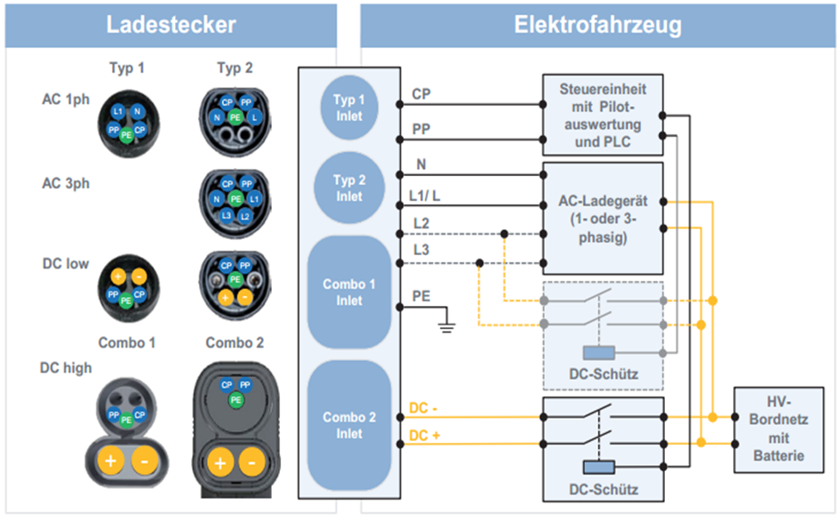

In the Figure 2.1 Signal contacts shown are defined as follows:

|  |  |  |
| --- | --- | --- |
| abbreviation | Contact | function |
| CP | Control pilot | Control signals charging station🡪electric vehicle |
| PP | Proximity pilot | Check the presence of a charging cable |
| N | Neutral | For AC charging |
| L1, L2, L3 | Current-carrying phases | For AC charging with a (L1 / L) or three (L1, L2, L3) Phases |
| PE | Protective Earth | protective conductor |
| DC +/- | Current-carrying phases | For DC charging |

* 1. IEC 61851

The IEC 62196 is an international standard for a number of types of plugs and charging modes for electric vehicles and of the International Electro technical Commission maintained (IEC). The standard is valid in Germany as a DIN standard DIN EN 62196. It consists of several parts which have been passed in succession. The third part was published in June 2014. In June 2015, the standardization process for part 4 (light- weight electrical connections) began.

The standard adopts the IEC 61851 definition for a signal pin that switches the charging current - the charging station remains de-energized until an electric vehicle is connected. During the charging process, the vehicle cannot be put into operation.

Prior to the definition of a charging process according to ISO / IEC 15118, the charging parameters required for the charging process were defined using a PWM signal according to IEC 61851. The signals of the Control Pilot (CP), Protective Earth (PE) and Proximity Pin (PP) contacts described in section 2.1 are required to determine the parameters required for loading.

For charging the vehicle, both communication subscribers are first connected to one another. A 1 kHz signal with 12V is generated on the CP contact from the side of the charging column. The pulse width of the signal indicates which maximum power can be provided by the charging column. In this case, 10% max. 10A, 25% 16A, 50% max. 32A and 90% quick charge (Wiki_Stecker, 2016).

On the vehicle side, resistors are connected between CP and PE or PP and PE. Different charging states are indicated by different switchable levels of the voltage between the CP and PP contacts, as shown in Figure 2.2. Please note that the negative voltage value is permanently -12V, and only the positive values ​​change. A definition of the individual states is Table 2.2.

Lastly, a vehicle-side resistance between the PP and the PE contact indicates the maximum possible charging current of the electric vehicle. The greater the resistance used, the lower the maximum charging current. Specifically, for a 1.5kΩ resistor, a maximum charging current of 13A, a maximum of 20A with a resistance of 680Ω, at 220Ω the maximum charging current 32A and 63A is at 100Ω.

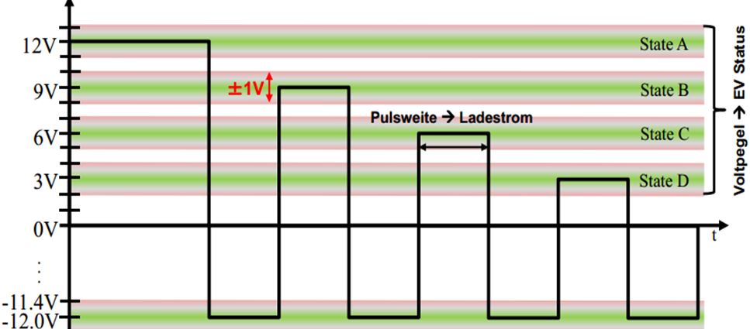

|  |  |  |
| --- | --- | --- |
| Level | State | Condition Description |
| 12 ± 1 V | State A | Electric vehicle is not connected |
| 9 ± 1 V | State B | connected electric vehicle, not charging Ready |
| 6 ± 1 V | State C | connected electric vehicle, ready to charge |
| 3 ± 1 V | State D | connected electric vehicle, ready for loading, ventilation needed |
| 0 ± 1 V | State E | Network problem, PP Short to earth |
| -12V | State F | Vehicle unavailable Error |

* 1. ISO 15118

The International Organization for Standardization (ISO) and the International Electronic Commission (IEC) in 2009 started to describe the standardization of a "digital IP-based communication protocol" between electric vehicle and charging station( Mültin, 2014), This should be a "plug-and-charge" mechanism for authentication, authorization, accounting, and for load control, so that needed to load enable parameters are stored in the vehicle and the user both communication parties must connect only. The individual communication Content will be the level of tension control pin signal from Chapter2.2 correspondingly Figure 2.3 assigned.

The full schedule of communication stacks for AC or DC charging an electric vehicle according to ISO / IEC 15118 can be found in Figure 7.1 to Figure 7.4, an overview of the variables contained in the messages within the AC communication stack is described together with an overview of the ISO / IEC 15118 in a previous study, work (Barth, 2015)

* + 1. Open V2G Project

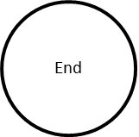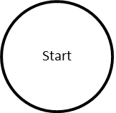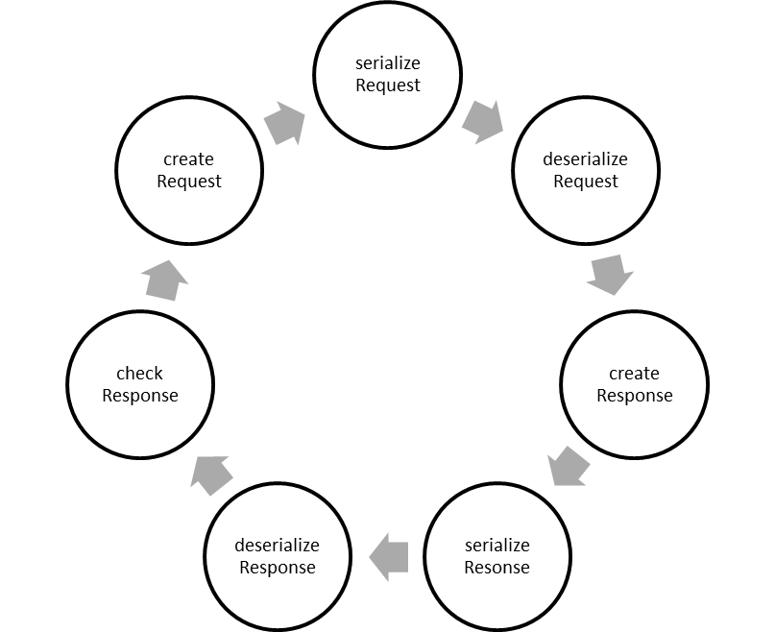An already far-reaching example for the implementation of a communication pack according to ISO / IEC 15118 has already been initiated by the support of Siemens Corporate Technology as Open Source project (OpenV2G, 2016). Both the loading column and the vehicle side are displayed in a program code and the messages are generated, checked, and the next message is generated. At the current status (version 0.9.3), the sequence of the individual requests and responses as well as the message contents to the direct current and alternating current charge can be derived very well. It is one of the objectives of this thesis to divide this code into a program for every communication user.

* 1. TCP/IP Communication: